Objective:
To examine the accuracy of the process over the cash in County Treasury reconciliations.
Scope and Methodology:
Monthly review of the reconciliation of the district’s records in the PSFS and FIN general ledger account # 9110 against the Los Angeles County Auditor-Controller eCAPS account fund QA1.
The review will address the following:
- Timely reconciliation – The reconciliation was prepared on a timely basis and the reconciling items were adjusted or corrected accordingly.

- Mathematical accuracy – The dollar amount is validated for accuracy and the total amount is footed and cross-footed.

- Management Review of Reconciliation – Management reviewed and approved the reconciliation on a monthly basis. Cash reconciliation documents are reviewed and approved by the Division Director or designee.

Cash Reconciliation Review Procedure:
- Confirmation of cash balances:

- Obtain a copy of the cash reconciliation as of the cut off date and trace the reconciled book balance to the general ledger, or trial balance as applicable.

- Print a cut off Balance Sheet Detail Activity by Fund report from eCAPS and confirm eCAPS balance on the reconciliation.

- Any differences are analyzed. After segregating the timing differences, amounts needed to be adjusted are identified.

- Amounts identified to be adjusted or corrected are communicated to SFS units involved and to the districts for documentation.

- Review all supporting documents and ensure all correcting entries are prepared and booked timely. Note: For internal control purposes staff from the cash reconciliation unit are not allowed to prepare and book any adjusting or correcting entries.

- Prepare a summary cash reconciliation report using the general ledger balances appearing in the PSFS/FIN report and in eCAPS detailed balance sheet report as of the reconciliation cut off date. The total amount between the two financial systems should agree after all outstanding reconciling items were added or deducted from the general ledger balances as of the cut off date. If there are any differences, further review and validation of numbers must be performed. Total amount is footed and cross-footed.

- Test of the Cash Reconciliation:

- Review the nature and extent of the reconciling items (primarily deposit in transit and outstanding warrants) for reasonableness.

- Review the detailed list of outstanding warrants and compare the total with the reconciliation summary.

- Review the detailed list of deposit in transit and compare the total with the reconciliation summary.

- Obtain an explanation and make the necessary follow ups for reconciling items that have not cleared in the subsequent period.

- Consider whether the result of the review indicate items for further investigation.

- Review and Approval Process:

- Verify the dollar amounts appearing in the reconciliation are validated for accuracy and the total amount is footed and cross-footed.

- Adjusting or correcting entries are approved by the district and SFS Accounting Manager or designee and input into the PSFS/FIN or eCAPS financial system in accordance with standard procedures.

- The time frame for completion of monthly reconciliation and corresponding adjusting entries is no later than a month after closing of the books.

- The monthly reconciliation is signed by the preparer, reviewer, and approver.

- The signed and approved cash reconciliation and supporting documents are filed for periodic review of the external auditors or other interested parties.

Sub Reconciliations:
- Deposit
- Payroll
- B Warrants
- Taxes
- JV

Basic Reports Required:
- PS Cash Other
Source: PSFS PUBLIC QUERY: CL_A _CASH_DWNLD_OTHERS
- Logon to PS
- Click on GO, People Tools, and Query
- Open Query
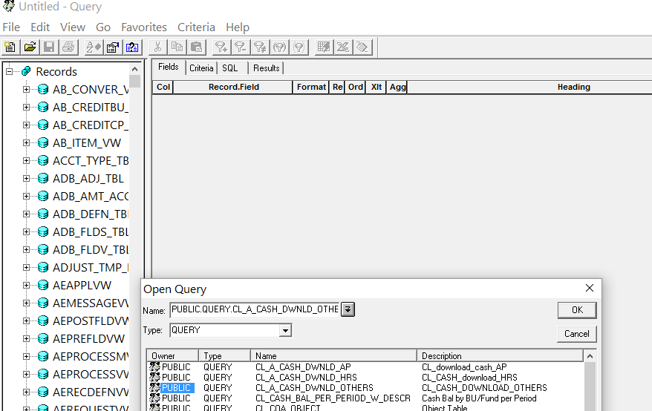

- Enter in Name CL and click arrow down.
- Select PUBLIC QUERY CL_A _CASH_DWNLD_OTHERS
- Click OK.
- Screen below will appear.
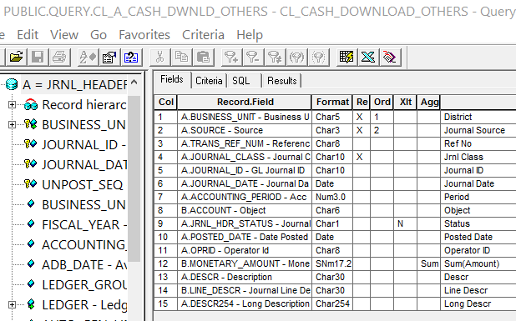

- Click on X (tool bar 2nd from right)

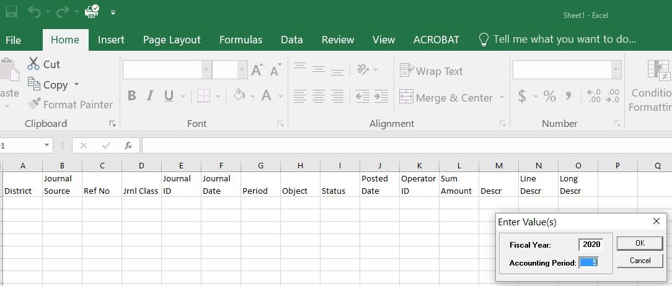

- Enter Fiscal Year and Accounting Period.
- Click OK.
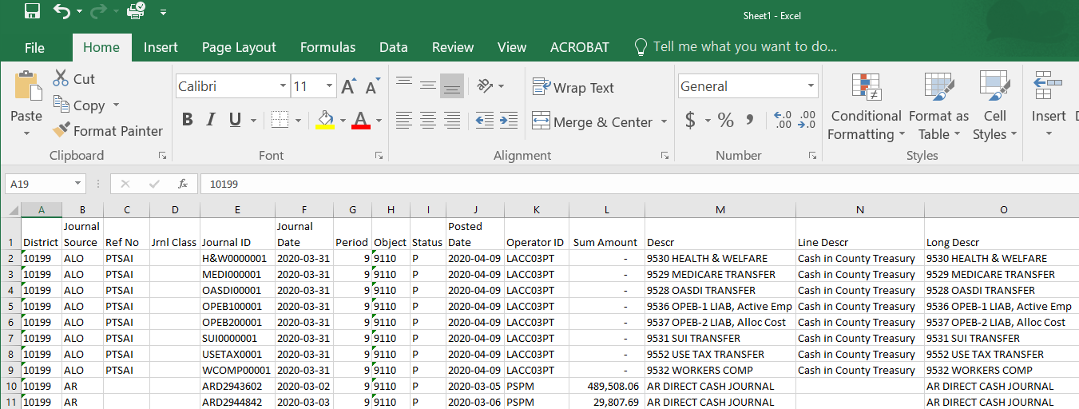

- Download worksheet (WS) to in excel
- Insert column on the left “Type” and using parameters below, classify type of transaction. Transactions will be classified as Deposit, AP, HRS, JV and Tax:

Create Pivot Table in tab 3 of all the above reports to show the amounts sorted by Type of Transactions, eg: Deposit, Payroll, B-Warrants, Taxes, JV.

These basic reports are used for all sub-reconciliations.
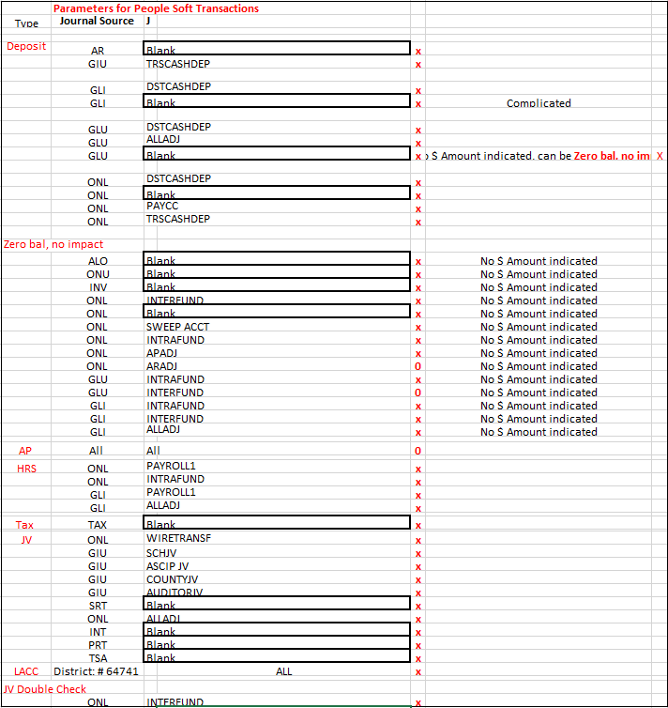

- FIN Cash Transactions
Source: FIN Report ID: FIN-RR-0001

- Login to CGI Advantage

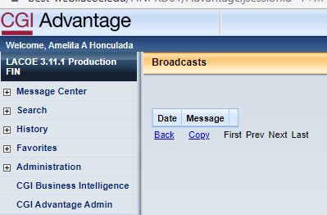

- Click on CGI Business Intelligence
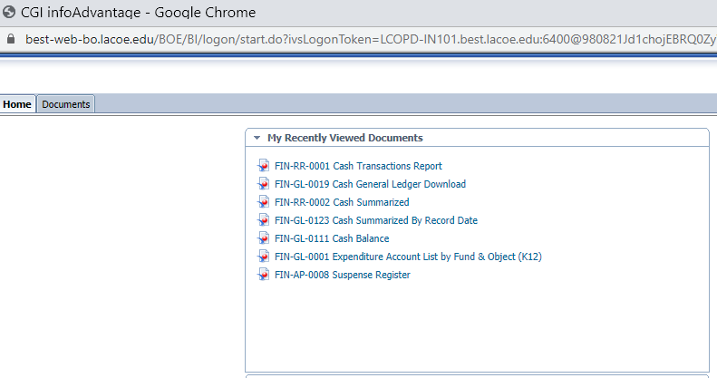

- Click on FIN-RR-0001 Cash Transaction Report
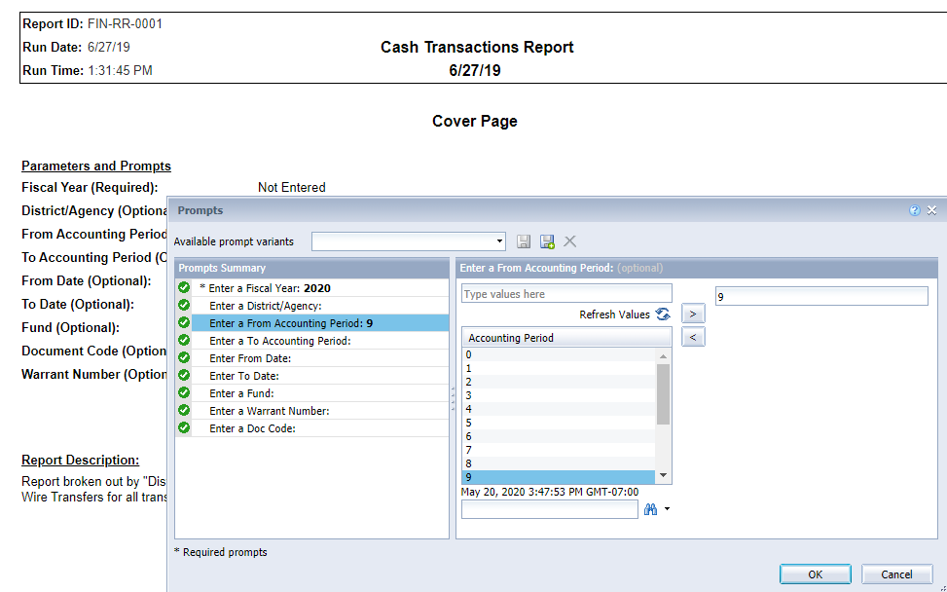

- Enter the Fiscal Year (above is 2020)
- Enter the Accounting Period (above is period 9)
- Click OK

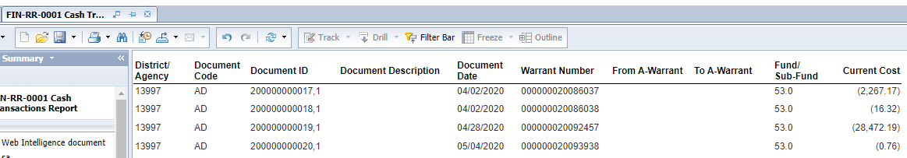

- Export document as Excel
- Open excel report

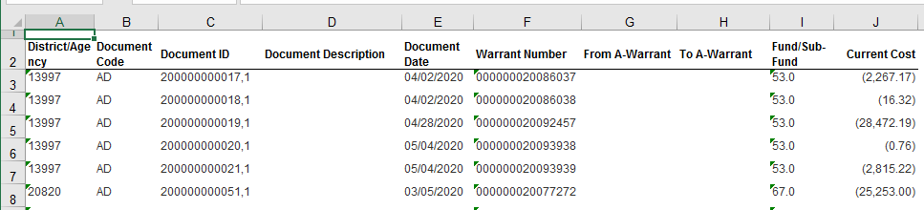

- Download worksheet (WS) to in excel
- Insert column on the left “Type” and using parameters below, classify type of transaction. Transactions will be classified as Deposit, AP, HRS, and Tax:
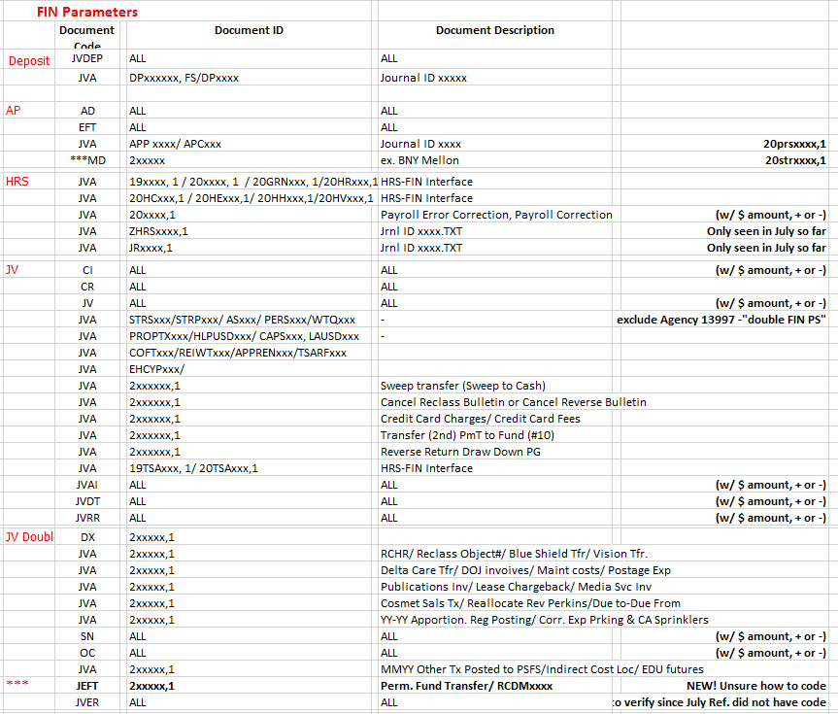
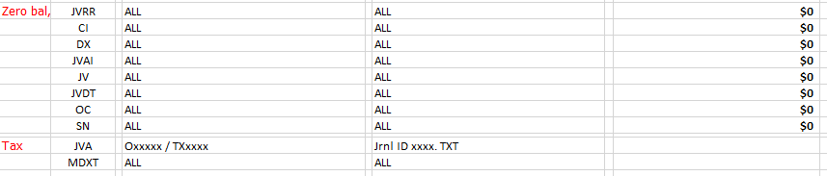
- eCAPS
Source: QA1 Balance Sheet Detail Activity by Fund report from eCAPS Portal
- Run eCAPS report
- Sign in to Auditor-Controller Contractor SSLVPN

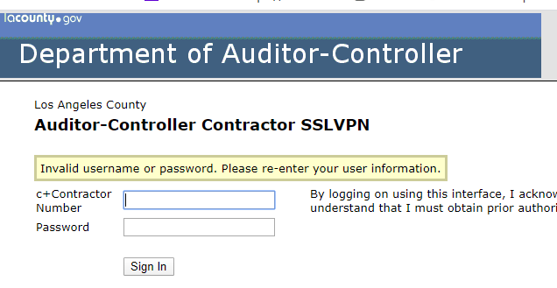

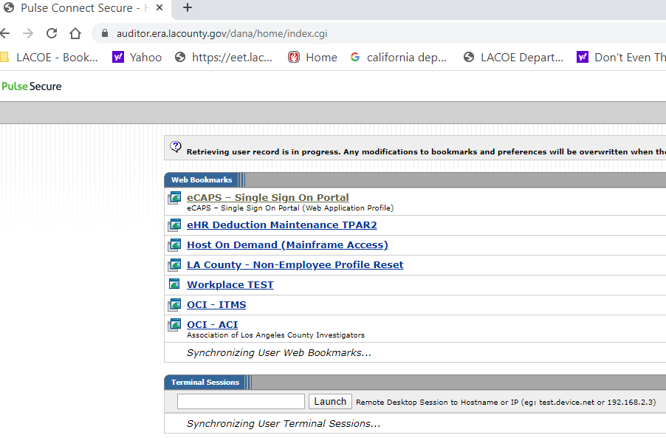

- Click on eCAPS – Single Sign on Portal
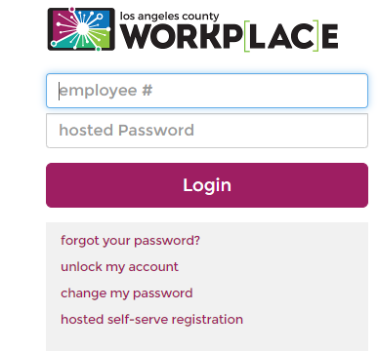

- Log in

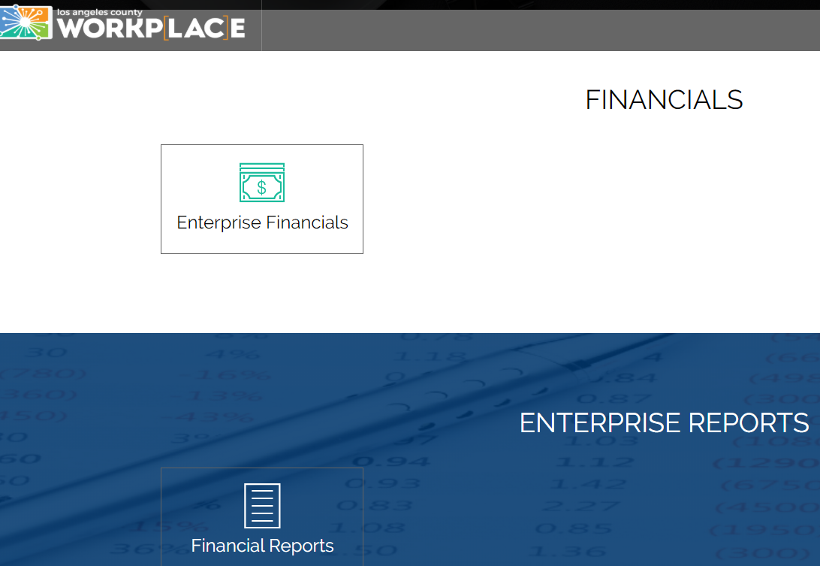

- Click on Financial Reports

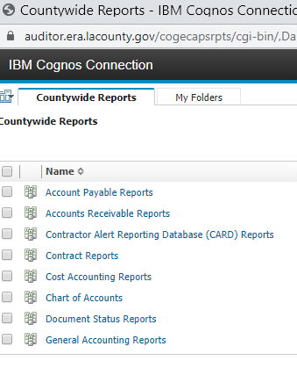
- Click on General Accounting Reports

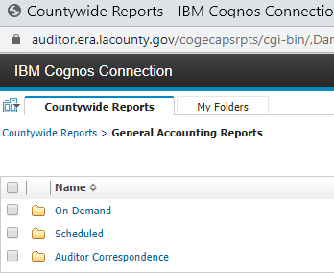

- Select On Demand
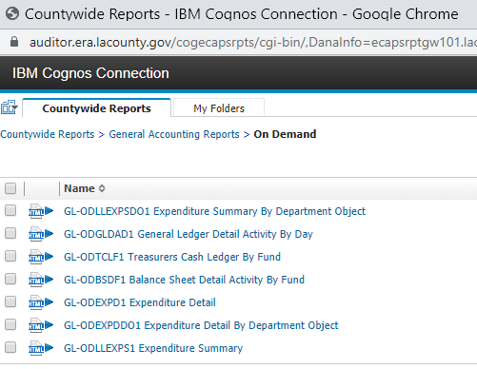

- Select GL-ODBSDF1 Balance Sheet Detail Activity By Fund report

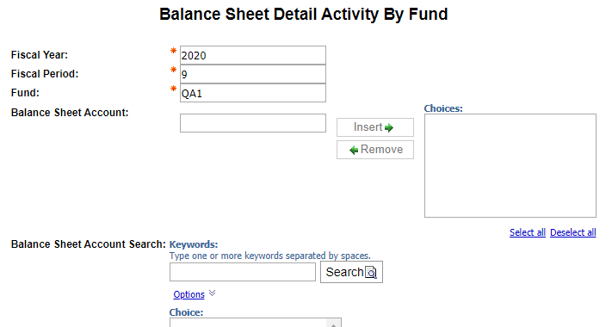

- Enter Fiscal Year
- Enter Fiscal Period
- Enter Fund
- Press Enter

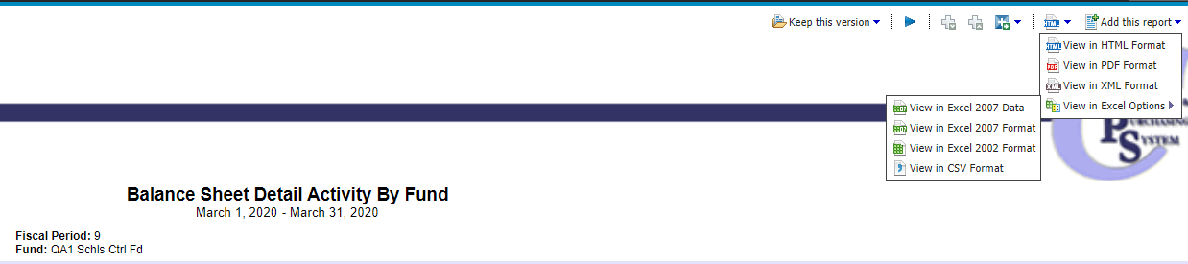
- Select View in PDF Format and Save

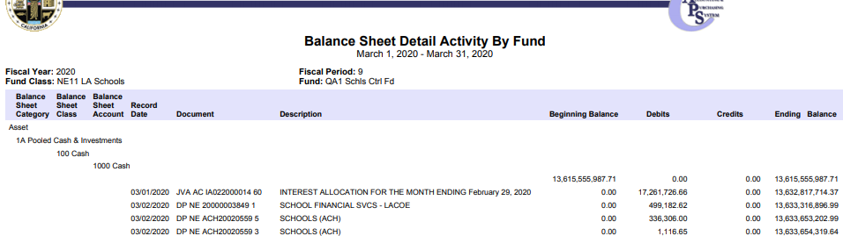

- Select View in Excel 2007 Data
- Open GL report and Save
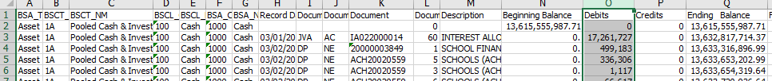
- Save worksheet (WS) to computer
- Insert column on the left “Type” and using parameters below, classify type of transaction. Transactions will be classified as Deposit, AP, HRS, and Tax:
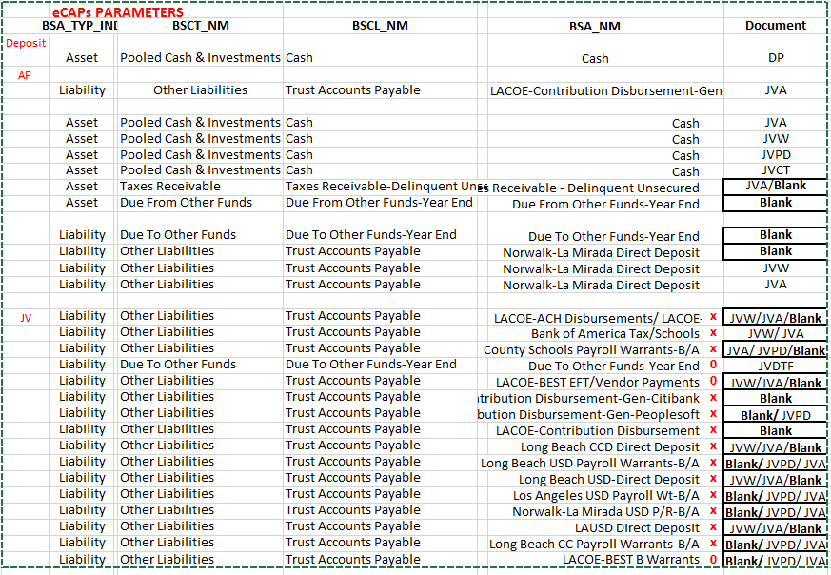
Reconcile data in PSFS & FIN to see if offsets with data in eCAPS.

Reasons why the following accounts are included in cash recon:
- Trust account payable:

Below is an example from eCAPs June 2022. Ending balance of $2.2B represents the uncashed warrants at the end of the month. It means that there is a payable balance of $2.2B as the issued warrants have not been cashed yet, but it also means that LA County still have $2.2B in fund QA1, thus, we need to include this balance in our cash recon.

Note 1: LA County pay the payees’ banks (when the warrants are cashed) via BOA and Citibank. Banking unit perform BOA / Citibank bank recs.

Note 2:

· Warrants paid (debit): cashed warrants.
· Wire transfer (debit): payments made via wire transfer.
· Issue amount (credit): for example, May Issue amount below: $260,462,884: this is the total amount of issued warrants/ wire transfers. Banking unit prepare the JV to book this amount.

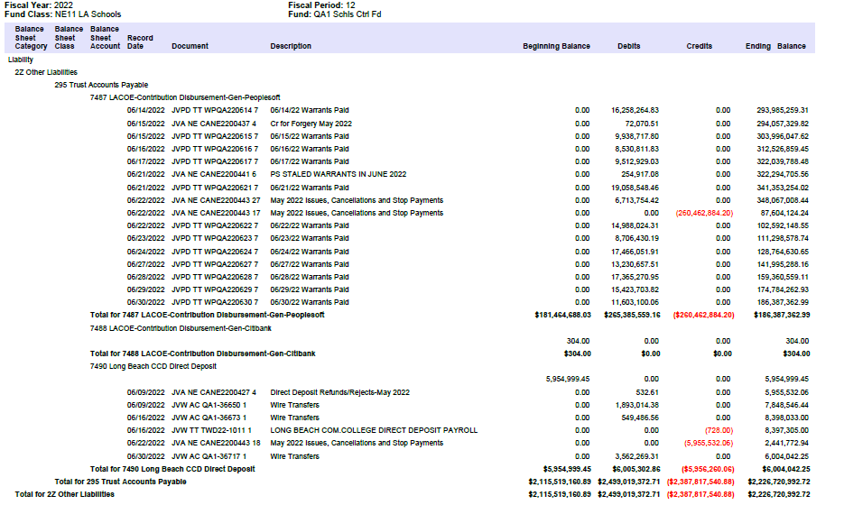

- Due from other funds/ Due From Other Funds-Year End:

LA County use these accounts to record the following:
· Tax and Revenue Anticipation Notes (TRANs) that are set aside probably in accordance with the Debt Official Statement. Entries will be: Dr Due from other funds/ Cr Cash. However, it means LA County still keep the money in fund QA1. Thus we need to account for this balance in our cash recons.

When the TRANs are mature/ paid to the investors:
Dr Cash / Cr Due from: to reverse the entries above
Dr Fiduciary / Cr Cash: to record the payments.

Normally these entries are booked on the same day.
· Investment interest (i.e. $11M we discussed with R&A yesterday), and Property taxes (due from LA County):
Entries are:
Dr Due from/ Cr Fiduciary: when Investment interest or Property tax apportionments are calculated.
Dr Cash/ Cr Due from: when Investment interest or Property tax apportionments are distributed to LACOE.

These entries are normally booked on the same day but could be to different periods, i.e. 998 2022 and FYE 2023 (i.e. the $11M inv interest).

Normally, the entries to record interest or Property taxes are offset eventually, and most of the time the ending balance of “Due from” is zero, unless there are TRANS or outstanding interest or property taxes at the year end. We usually include “Due from other funds/ Due From Other Funds-Year End” in our cash recon regardless of interest, property taxes or TRANs and the recon item, if any, will be cleared in the subsequent period. We can continue this practice, to simplify the process, or need to perform further analysis to include only the TRANs portion, but we need to do it consistently.

- Due To Other Funds-Year End:

LA County usually use this account to record bank charges/ management fees. Entries:
Dr Fiduciary/Cr Due to: when the fees are calculated.
Dr Due to/ Cr cash: when the fees are deducted from the cash balance of QA1.

These entries are normally booked on the same day but could be to different periods. Recon item, if any, is cleared in the following months. Audit & Recon Accountant and/or Banking unit prepare JVs to record bank charges/ management fees based on the balance of this “Due to” account. Hence, the best practice is to include the “Due to” bal in our cash recon so that we can see the o/s bank charges/ fees.

We never need to ask LA County any question about their JVs or ask for their supporting documents (except for the JVs that are prepared by Banking Unit (i.e. Monthly issued payroll/ B warrants). We can see the accounting strings in eCAPS by searching all relevant JVs in eCAPS.

Outstanding items from prior months that cleared in current month should be entered along with the outstanding items in the current month, in Cash Summary. Variance should show “0”.
Email the reconciliation report to Christine Le & Christina Hill for review.
Send e-sign pdf to approval from:
- Myself – The Preparer
- Christine Le
- Christina Hill
Save the approved/signed copy of esign pdf in Cash Recon folder for the month.

Prepared By: Geeta Bhatt

